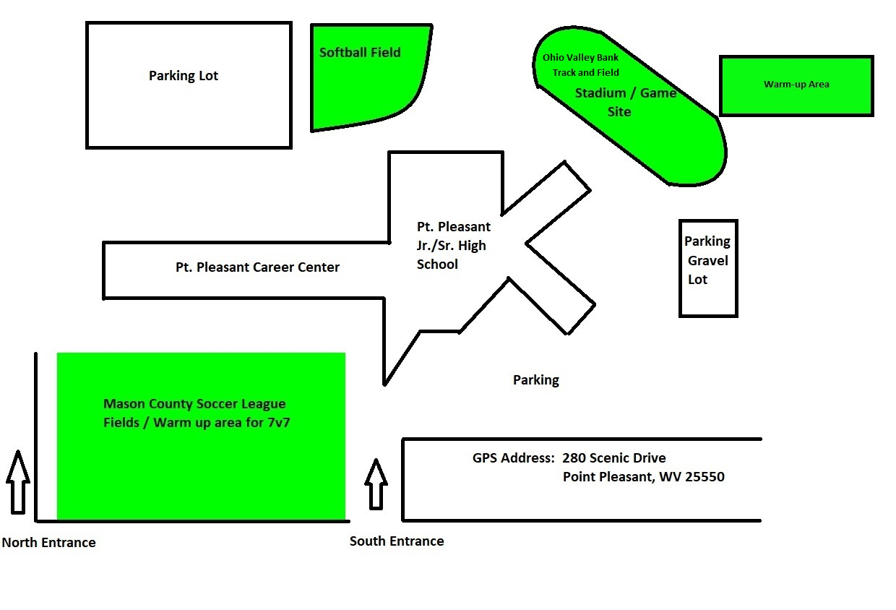General Notes:

* Teams may warm-up on grass in front of school or the field behind visiting bleachers
* Teams may set up tents under the home bleachers, in the visiting bleachers, or at the very top of the home side bleachers
* The area under the home bleachers is shaded but it is filled with gravel, so you may want to bring mats or blankets to lay/sit on
* Concession stand will be open
* Trainers will be on duty throughout the duration of the tournament.